Normal Force Stabilizing Control Using Small EV
Powered only by Electric Double Layer Capacitor

Kiyotaka Kawashima
Department of Electrical Engineering, University of Tokyo
7-3-1 Hongo, Bunkyo-ku, Tokyo113-8654 Japan
Tel:+81-3-5452-6289 Fax:+81-3-5452-6288 E-mail:kawashima@horilab.iis.u-tokyo.ac.jp

Toshiyuki Uchida
Department of Electrical Engineering, University of Tokyo
E-mail:uchida@horilab.iis.u-tokyo.ac.jp

Yoichi Hori
Department of Electrical Engineering, University of Tokyo
E-mail:hori@iis.u-tokyo.ac.jp

Abstract
This paper has two topics. The first one is development of novel electric vehicle powered only by "Electrical double layer capacitor (EDLC)". The second one is normal force stabilizing (NFS) vehicle motion control using this vehicle. This vehicle provides us useful experimental environment of electric vehicle motion control, since EDLC power system can shorten charging time. 2 minutes charging enables us 20 minutes driving. The development of small EV and the vehicle control system are shown. Novel vehicle stabilizing control method using acceleration information is proposed. Normal force has strong connectivity with driving force and its sudden decrease causes tire slip, which makes the whole vehicle motion unstable. The simulation and experimental results are shown and its effectiveness will be discussed.

Keywords: A-2.2 Light Vehicles, B-1.1 On-Board Energy Storage System, B-6.2 Double layer capacitor, Vehicle Motion Control

1 INTRODUCTION
EDLC, whose energy density has drastically increased, is drawing much attention. EDLC has a lot of advantages as following [1].

1. It can be charged and discharged very quickly without heat generation because it is not based on chemical reaction.
2. Capacitor’s voltage level tells us the remaining energy level very precisely.
3. Capacitor is very tough to endure the repetitions of charging and discharging.
4. Capacitor is environmental friendly because it does not use heavy metals.

Capacitors have been used as fbackup batteries of mobile PC’s, printers, UPS’s, etc. In the field of automobile, some fuel-cell (hybrid) vehicles use capacitors not only for absorbing the regenerated energy but also for compensating the low efficiency of fuel-cell battery. Long life duration of EDLC is also useful for starter battery of vehicles.

The aim of making the capacitor vehicle is to develop the useful experimental environment of vehicle motion control taking the advantage of the peculiar characteristic of large current charging. In the following section, the development of small EV “Capacitor COMS (C-COMS; Figure 1(a))” and the vehicle control system are described. The vehicle normal force stabilizing (NFS) control method is also proposed. Normal force has strong connectivity with driving force and its sudden decrease causes tire slip, which makes the whole vehicle motion unstable [2]. Basic simulation and experimental results of NFS control will be given in the third section.
2 Development of small electric vehicle powered only by EDLC
EDLC modules (100V, 80F) are installed on the small electric vehicle (Figure 1(b))
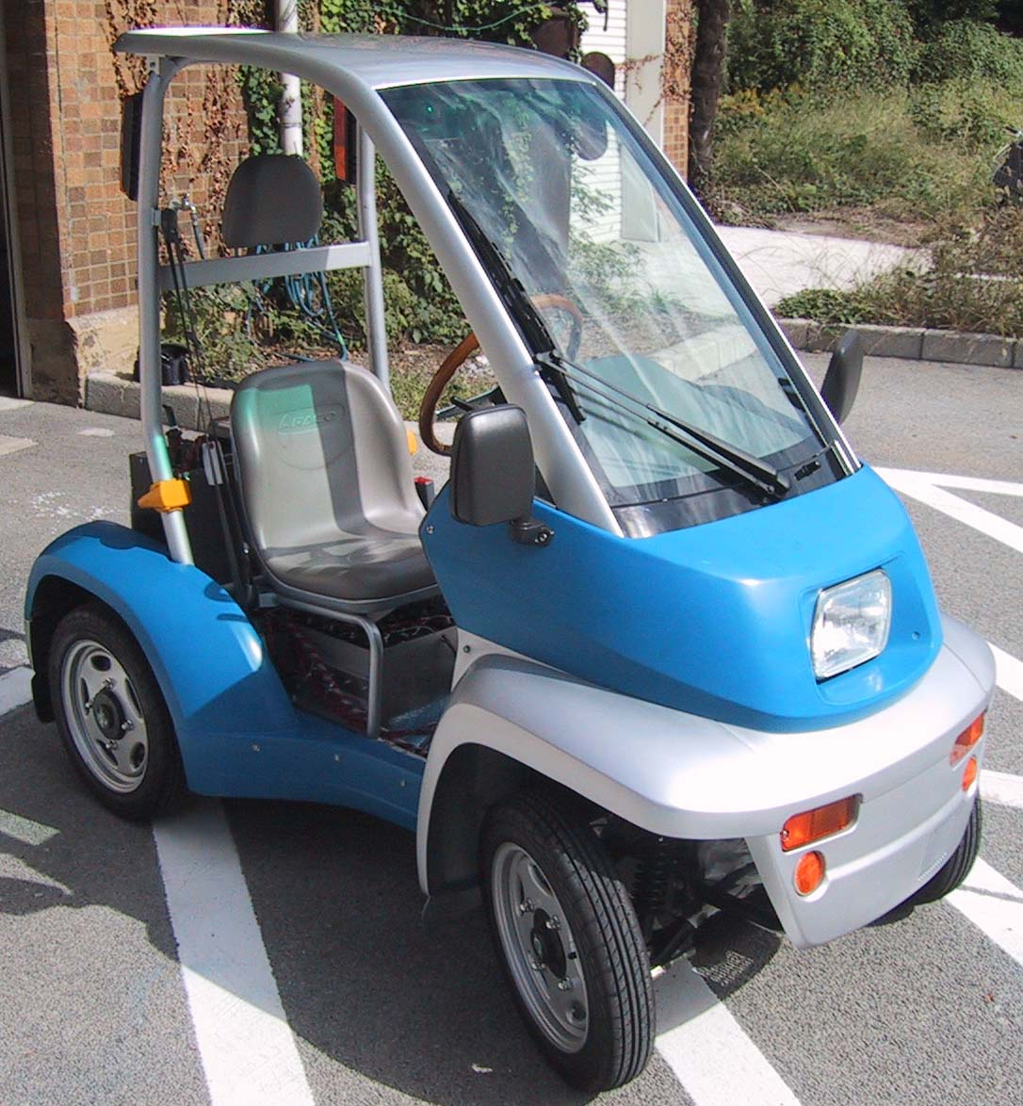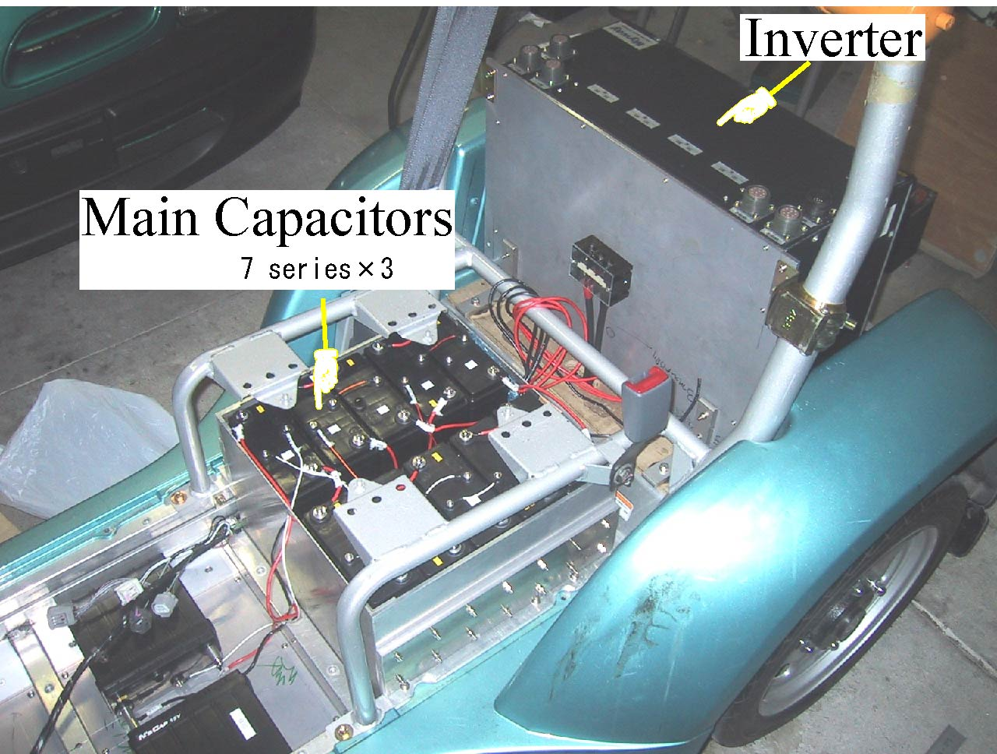
(a)Overall view of C-COMS (b) Capacitor modules and inverter
Figure 1: Capacitor-COMS
2.1 Merit of EDLC application for EV
EDLC application for EV has following advantages which secondary batteries don’t have.
1. Large current charging
- Voltage level tells us remaining energy level
- Durable for repetitive charge/discharge
- Environmentally friendly
Theoretically EDLC is not based on chemical reaction and its internal resistance is small, Large current charging is possible. EDLC is also more than 100 times as durable as for repetition of charging and discharging. In addition, EDLC voltage level tells us remaining energy level very precisely against the estimation of energy level on secondary battery is very difficult. 2 minutes charging realizes 20 minutes driving. EDLC application for EV has these attractive advantages.
Table 1 shows the comparison of EDLC parameters with other secondary batteries.

Table 1: Comparison with other secondary batteries
 | Energy density |  | Power density | Cycle
 | Wh/kg | Wh/l | W/kg
Lead | 36 | 95 | 200 | < 500
NiMH | 65 | 155 | 200 | < 500
Li-ion | 110 | 160 | 200 | 500
EDLC | 11 | 11 | 1100 | Semi permanent
Although the EDLC’s energy density is very small, the power density is more than 5 times as large as other devices and cycle life is semi permanent. These characteristics enable fast charging and make an electric vehicle suitable for experiments, where lots of experiments are needed in the same condition in short experimental time.

2.2 EDLC specification
Table 2 shows the specification of EDLC module installed in C-COMS. Although the EDLC’s energy density is very small, the power density is about 10 times as large as other storage devices and cycle life is semi permanent.
Table 2: Specification of EDLC module
Voltage | 15V
Capacitance | 200F
Energy density | 10.7Wh/L
Power density | 10.8kW/L
Internal Resistance | 5.5$mΩ$
Mass | 1.5kg
Volume | 155mm×66mm×154mm
Number of modules | 21
2.3 Vehicle specification
Our small vehicle named C-COMS is a one-seater vehicle with two in-wheel motors. Drive train consists of batteries, inverters and permanent magnet synchronous motors.
Table 3 shows its details.
Table 3: Drive train of C-COMS
Motor
Category | PSM
Phase/Pole | 3/12
Rating power/Max | 0.29kW/2kW
Max torque | 100Nm
Max speed | 50km/h
Inverter
Hardware | Transistor inverter
Control method | PWM vector control
The original inverter could not give the torque command to each motor independently and it has about 300 msec time lag from the acceleration command to the motor.
Therefore we designed a new inverter which can command torque independently and has little time lag to realize novel motion control of vehicle dynamics.
  - Development of Capacitor-COMS
Figure 2 shows the vehicle control system.
We developed following four new components which the original electric vehicle did not have.
- ECU (Electrical Control Unit) for generating torque command and storing experimental data
- EDLC box and newly designed inverter mounting
- Speed detector using PIC (Peripheral Interface Controller)
- Steering encoder, acceleration/gyro sensor mounting
ECU was developed using PC104 standard embedded PC module. The merit of using this standard is that this PC is very small and has high extendibility. ECU consists of CPU boards, DC/DC converter, 12V fun, USB hub. AD board reads the acceleration command and ECU calculates the required torque command. Sensors’ information and state variables are logged and stored in 2.5 inch hard disk drive.
EDLC box was manufactured for installing the EDLC modules. 21 EDLC modules (7 series × 3) are installed in this vehicle.
Speed detector from the magnet sensor pulses was developed using PIC. In-wheel motors have magnet speed detector. Three pulses are output together with 120(deg) phase lag each. We used PIC, which is very small (8 pin DIP) and inexpensive, for processing the three phase pulses conversion. PIC converts the three pulse signal into the speed pulse and the rotational direction signal.
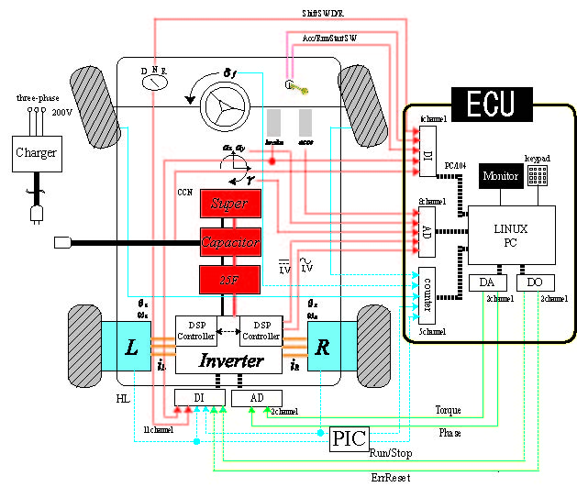
Figure 2: Vehicle control system
- Normal force stabilizing (NFS) control using acceleration information
3.1 Motion control on electric vehicle
Merit of electric motor
As we have pointed out, electric vehicle has the following four remarkable advantages [3][4]:

1. Motor's torque generation is 10-100 times faster than engine. This advantage enables us to realize high performance adhesion control, skid prevention and slip control.
- Motor’s torque can be known easily by observing the motor current. This property can be used for road condition estimation.
- As a motor is compact and not so expensive if it is divided into four, it can be equipped for each wheel. This realizes high performance vehicle motion control.
- There is no difference between acceleration and deceleration control. Just by changing the direction of motor current, the vehicle can be decelerated.
Utilizing these advantages slip prevention control, road condition estimation, yaw rate control and other vehicle stabilizing control methods had been proposed. For example, control with independent wheel torque control [5], yaw-moment stabilizing control using yaw-moment observer [6] had been studied. Self-aligning torque estimation [7] and cornering stiffness estimation [8] are also important research subjects.
3.2 Normal force stabilization control
We will show you that normal force on each tire can be calculated by using acceleration information. Considering of moment balance, mobility of hypothetical center of gravity (HCG) can be estimated by these normal force. Here, hypothetical means that suspension system is not taken into account.

3.2.1 Difference with other conventional two-dimensional control method
As two dimensional control method, so many of $γ$ or $β$ feedback control methods are proposed. But either method is limited in two-dimensional surface. We focus on that normal force on each tire is calculated using acceleration information and it is possible to estimate mobility of HCG. The purpose of NFS is to control mobility of HCG with differential torque. The different point from other conventional method is unlimited to the two-dimensional surface, but taking into account the vehicle rolling motion.
Where M is vehicle weight, g acceleration of gravity, ax and ay vehicle longitudinal and lateral acceleration, h height of HCG from ground, $l_{f}$ and $l_{r}$ distance between HCG and front and rear shaft, d right and left tire distance, $δ_{f}$ steering angle.
    - Normal force calculation on each tire
Figure 3: Normal force on each tire
Figure 4: Calculation of normal force
Considering of moment balance, the normal forces on the center of front and rear shaft (figure3,4) are given by Eqs. (1) and (2).
$F_{z−f}=\frac{M}{l_{f}+l}(l_{r}g+{\text{ha}}_{x})$ (1)
$F_{z−r}=\frac{M}{l_{f}+l}(l_{f}g−{\text{ha}}_{x})$ (2)
Normal force on each tire is calculated as following equation.
$\begin{aligned}F_{z−\text{fr}}=\frac{1}{2}\frac{M}{l_{f}+l}(l_{r}g+{\text{ha}}_{x})+\frac{{\text{hMa}}_{y}}{d} \\ F_{z−\text{fl}}=\frac{1}{2}\frac{M}{l_{f}+l}(l_{r}g+{\text{ha}}_{x})−\frac{{\text{hMa}}_{y}}{d} \\ F_{z−\text{rr}}=\frac{1}{2}\frac{M}{l_{f}+l}(l_{r}g−{\text{ha}}_{x})+\frac{{\text{hMa}}_{y}}{d} \\ F_{z−\text{rl}}=\frac{1}{2}\frac{M}{l_{f}+l}(l_{r}g−{\text{ha}}_{x})−\frac{{\text{hMa}}_{y}}{d}\end{aligned}$ (3-a,b,c,d)
3.2.3 Mobility of hypothetical center of gravity (HCG) estimation
Defining$Δx$, $Δy$ as mobility of HCG (normal force instability indices), the momentum balance equation in longitudinal direction is expressed by equation(4).
$−F_{z−f}(l_{f}−Δx)+F_{z−f}(l_{r}+Δx)=0$ (4)
$Δx$ is given as following equation
$\begin{aligned}Δx=\frac{F_{z−f}l_{f}−F_{z−r}l_{r}}{F_{z−f}+F_{z−r}} \\ =\frac{a_{x}}{g}h\end{aligned}$ (5)
In a similar way,
$Δy=\frac{a_{y}}{g}h$ (6)
The indices $Δx$, $Δy$ are proportional to the acceleration. To suppress$Δy$, differential torques are commanded on each motor. Figure 5 shows the block diagram of this control method.
Figure 5: NFS control diagram

4.2.4 Simulation results of NFS control
The simulation result in right turning and sinusoidal steering input are shown in figure 6. In actual experiment, acceleration information contains much noise, we need to eliminate noise with low pass filter.
Figure 6: Simulation result with step steering input
For simplifying the problem, the reference variable ${Δy}^{}$ is designed as zero. It is impossible to suppress $Δy$ to zero because of torque saturation. But this simulation result shows the effectiveness of NFS control.
- Experimental of NFS
5.1 Experimental condition
Experimental conditions is that driver turn the steering wheel as step and sinusoidal under the constant velocity. Experimental terms are followings,
- Step steering input, ${Δy}^{}$ is zero
- Sinusoidal steering input, ${Δy}^{}$is zero
- Step steering input, ${Δy}^{}$ is generated from steering angle
- Sinusoidal steering input, ${Δy}^{}$ is generated from steering angle
5.2 Experimental result
In this section, 4 kind of experimental results are shown mentioned above.
    - Experimental result of HCG control when ${Δy}^{}$ is zero
To know the basic vehicle behavior with differential torques, NFS control experiment is applied when when ${Δy}^{}$ is zero. The experimental results of step and sinusoidal steering input are shown in Figure 7. With the larger control gain Kp, the differential torques on right and left tires suppress $Δy$ more effectively. These figures correspond to the simulation results in the previous section.
(a) Step steering input (b) Sinusoidal steering input
Figure 7: NFS experimental results when ${Δy}^{}$ is zero
    - Following capability of $Δy$ to ${Δy}^{}$
Next Figures are the cases that ${Δy}^{}$is generated as following equation using gain K,vehicle speed V.
${Δy}^{}=K⋅V⋅δ_{f}$ (7)
(a) Step steering input (b) Sinusoidal steering input
Figure 8: NFS experimental results when ${Δy}^{}$ is generated from steering angle
Fine $Δy$ suppression and following capability to ${Δy}^{}$ is verified with these results. Consequently, we can control and design the mobility of HCG in lateral direction, which is one of vehicle turning characteristics, by the differential torque of right and left motors. It is very important to control the mobility of HCG because it is related to not only “ride quality”, but also “vehicle active safety” in turning motion. Normal force has strong connectivity with driving force whose sudden decease would make vehicle motion unstable.

- Conclusion
In this paper, the development of experimental vehicle powered only by EDLC is introduced and novel vehicle stabilizing control method using lateral acceleration information is proposed. Short charging time realized by EDLC power system provides us useful experimental environment. The simulation and experimental results indicate the effectiveness of NFS control method. Dangerous steering input is effectively suppressed and $Δy$ is controlled with reference variables. By controlling$Δy$, the novel vehicle active safety is realized in turning motion.
References
[1] Michio Okamura, Electrical double layered capacitor and storage system (in Japanese), pp.25-31, Nikkan-Kogyo-Shimbunsya
[2] Masato Abe, Vehicle dynamics and control (in Japanese), Sankaido, 1992
[3] Yoichi Hori, ”Future Vehicle driven by Electricity and Control-Research on Four Wheel Motored ”UOT Electric March II”, IEEE Transaction on Industrial Electronics, Vol.51, No.5, October 2004
[4] Shinichiro Sakai et al.,”Novel skid detection method without vehicle chassis speed for electric vehicle, JSAE Review (Elsevier Science)”, Vol.21, No.4, pp.504, 2000
[5] Motoki Shino, Masao Nagai, ”Independent wheel torque control of small-scale electric vehicle for handling and stability improvement”, JSAE Review, Vol.24, pp.449-456, 2003
[6] Hiroshi Fujimoto, Takeo Saito, Toshihiko Noguchi,”Yaw moment stabilizing control of small electric vehicle”, AMC2004-Kawasaki, pp.35-40, 2004
[7] Daisuke Sekiguchi, Toshiyuki Murakami, ”Vehicle steering assist by estimated self aligning torque in skid condition”, AMC2004-Kawasaki, pp.269-273, 2004
[8] Akio Tsumasaka, Hiroshi Fujimoto, Toshiyuki Noguchi, ”Cornering stiffness estimation of electric vehicle based on yaw moment observer (in Japanese)”, National Convention Record IEE of Japan -Industry Applications Society-, pp.II 551-552, 2003

Author

Kiyotaka Kawashima
Department of Electrical Engineering the University of Tokyo, 7-3-1 Hongo Bunkyo-ku Tokyo 113-8656, Japan
Tel: +03 5452 6289, Fax: +03 5452 6288 E-mail: kawashima@horilab.iis.u-tokyo.ac.jp,
He received B.C. degree in Electrical Engineering from the University of Tokyo in 2004, and proceeded to master course in the University of Tokyo. He is now researching the motion control of electric vehicle and estimating the ELDC as the power source of electric vehicle.

Toshiyuki Uchida
Department of Electrical Engineering the University of Tokyo,
7-3-1 Hongo Bunkyo-ku
Tokyo 113-8656, Japan E-mail: uchida@horilab.iis.u-tokyo.ac.jp,
He is working as a engineering official in Department of
Electrical Engineering the University of Tokyo


Yoichi Hori
The Institute of Industrial Science the University of Tokyo,
4-6-1 Komaba Meguro-ku Tokyo 153-8505, Japan
Tel: +03 5452 6289, Fax: +03 5452 6288
E-mail: hori@iis.u-tokyo.ac.jp,
He received Ph.D degrees in Electrical Engineering from the
University of Tokyo in 1983 and joined the Department of
Electrical Engineering as a Research Associate. He later
became a Professor in 2000. In 2002, he moved to the Institute
of Industrial Science as a Professor of Information & Electronics Division. His research fields are control theory and its industrial application to motion control, mechatronics, robotics, electric vehicle, etc. He worked as Treasurer of IEEE Japan Council and Tokyo Section during 2001-2002. He is now an AdCom member of IEEE-IES. He was the Vice President of IEE-Japan IAS in 2004-2005. He has been the chairman of ECaSS Forum since 2005. He is the program chairperson of EVS-22. IEEE Fellow.

