Dynamic Center of Gravity Control using Experimental Electric Vehicle "Capacitor-COMS" with Extremely Quick Charging Capability
Kiyotaka Kawashima ª, Toshiyuki Uchida ª and Yoichi Hori ^{b}

ª Department of Electrical Engineering, the University of Tokyo, 7-3-1 Hongo Bunkyo Tokyo, 113-8565, Japan

^{b} Institute of Industrial Science, the University of Tokyo, 4-6-1 Komaba Meguro, Tokyo, 153-8505, Japan
kawashima@horilab.iis.u-tokyo.ac.jp, uchida@horilab.iis.u-tokyo.ac.jp, hori@iis.u-tokyo.ac.jp

Abstract — This paper has two topics. The first one is development of novel electric vehicle powered only by "Electrical Double Layer Capacitor (EDLC)". The second one is normal force stabilizing (NFS) vehicle motion control using this vehicle. This vehicle provides us useful experimental environment of electric vehicle motion control, since EDLC power system can realize short charging time. Only 30 seconds charging enables us 20 minutes driving and doing experiments. Firstly, the development of small EV and the vehicle control system are shown. Secondary, Novel vehicle stabilizing control method using acceleration information is also proposed. Normal force has strong connectivity with driving force and its sudden decrease causes tire slip, which makes the whole vehicle motion unstable. The simulation and experimental results are shown and its effectiveness will be discussed.

Keywords — Electric vehicle, Electric double layer capacitor, Vehicle motion control

I. INTRODUCTION
Electrical double layer capacitor (EDLC), whose energy density has drastically increased, is drawing much attention. EDLC has a lot of advantages as following [1].
1. It can be charged and discharged very quickly without heat generation because it is not based on chemical reaction.
2. Capacitor’s voltage level tells us the remaining energy level precisely.
3. Capacitor is very tough to endure the repetitions of charging and discharging.
4. Capacitor is environmental friendly because it does not use heavy metals.
Capacitors have been used as backup batteries of mobile PC’s, printers, UPS’s, etc. In the field of automobile, some fuel-cell and hybrid vehicles use capacitors not only for absorbing the regenerated energy but also for compensating the low efficiency of fuel-cell battery and secondary battery. Long life duration of EDLC is also useful for starter battery of vehicles.
The purpose of making the capacitor vehicle is to develop the useful experimental environment of vehicle motion control taking the advantage of peculiar characteristic of large current charging. In the following section, the development of small EV “Capacitor COMS (C-COMS; Fig. 1)” and the vehicle control system are described. The vehicle normal force stabilizing (NFS) control method is also proposed. Normal force has strong connectivity with driving force and its sudden decrease causes tire slip, which makes the whole vehicle motion unstable. Basic simulation and experimental results of NFS control will be given in the third section.
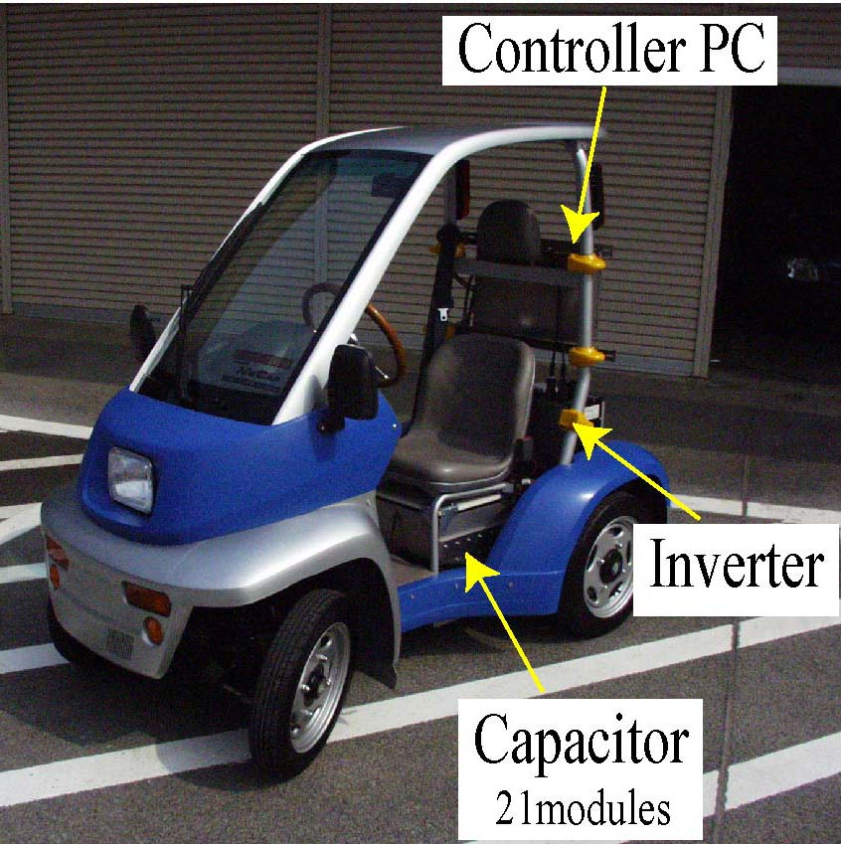
Fig. 1 Capacitor-COMS

II. Development of small electric vehicle
powered only by EDLC
A Merits of EDLC application for EV
EDLC application for EV has following advantages which secondary batteries don’t have.
As EDLC is not based on chemical reaction and its internal resistance is small theoretically, large current charging is possible. EDLC is also more than 100 times as durable as for repetition of charging and discharging. In addition, EDLC voltage level tells us remaining energy level very precisely against that estimation of energy level on secondary battery is very difficult. Less than 1 minute charging realizes 20 minutes driving. EDLC application for EV has these attractive advantages. Table I shows the comparison of EDLC parameters with other secondary batteries.
Table I Comparison with other secondary batteries

Although the EDLC’s energy density is very small, the power density is more than 5 times as large as other devices and cycle life is semi permanent. These characteristics enable fast charging and make an electric vehicle suitable for experiments, where lots of experiments are needed in the same condition in short experimental time.

B EDLC specification
Table II shows the specification of EDLC module installed in C-COMS. A Module has 5 cells and maximum voltage of each cell is 3.0V. 21 EDLC modules (7 series × 3) are installed on this vehicle.
Table II Specification of EDLC module

C Vehicle specification
Our small vehicle named C-COMS is a one-seater vehicle with two in-wheel motors. Drive train consists of batteries, inverters and permanent magnet synchronous motors. Table III shows its details.
The original inverter could not give torque command to each motor independently and it has about 300 msec time lag from the acceleration command to the motor. Therefore we designed a new inverter which can command torque independently and has little time lag to realize novel motion control of vehicle dynamics.

D Development of Capacitor-COMS
Fig. 2 shows the vehicle control system. We developed following four new components which the original electric vehicle did not have.
- ECU (Electrical Control Unit) for generating torque command and storing experimental data
- EDLC box and newly designed inverter mounting
- Speed detector using PIC
- Steering encoder, acceleration/gyro sensor mounting
Table III Drive train of C-COMS
ECU was developed using PC104 standard embedded PC module. The merit of using this standard is that this PC is very small and has high extendibility. ECU consists of CPU ADA and counter boards, DC/DC converter, 12V fun, USB hub. AD board reads the acceleration command and ECU calculates the required torque command. Sensors’ information and state variables are logged and stored in 2.5 inch hard disk drive.
Speed detector from the magnet sensor pulses was developed using PIC. In-wheel motors have magnet speed detector. Three pulses are output together with 120(deg) phase lag each. We used PIC, which is very small (8 pin DIP) and inexpensive, for processing the three phase pulses conversion. PIC converts the three pulse signal into the speed pulse and the rotational direction signal.
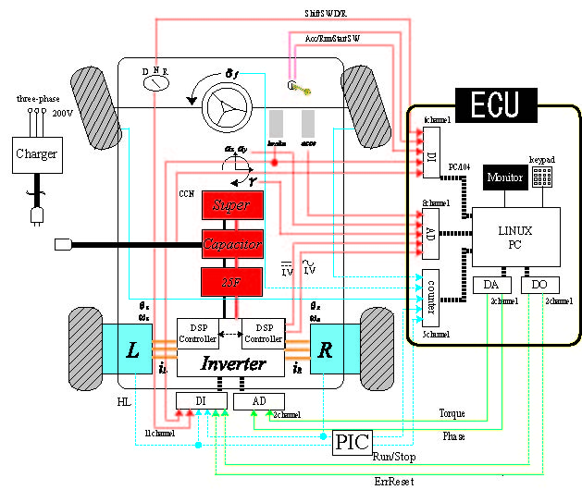
Fig. 2 Vehicle control system
III. Normal force stabilizing control using acceleration information
A Motion control on electric vehicle
As we have pointed out, electric vehicle has the following four remarkable advantages [2][3]:
1. Motor's torque generation is 10-100 times faster than engine. This advantage enables us to realize high performance adhesion control, skid prevention and slip control.
2. Motor’s torque can be known easily by observing the motor current. This property can be used for road condition estimation.
3. As a motor is compact and not so expensive if it is divided into four, it can be equipped for each wheel. This realizes high performance vehicle motion control.
4. There is no difference between acceleration and deceleration control. Just by changing the direction of motor current, the vehicle can be decelerated.
Utilizing these advantages slip prevention control, road condition estimation, yaw rate control and other vehicle stabilizing control methods had been proposed. For example, control with independent wheel torque control [4], yaw-moment stabilizing control using yaw-moment observer [5] had been studied. Self-aligning torque estimation [6] and cornering stiffness estimation [7] are also important research subjects.

B Normal force stabilizing (NFS) control
We will show that normal force on each tire can be calculated by using acceleration information. Considering of moment balance, mobility of hypothetical center of gravity (HCG) can be estimated by these normal forces. Here, hypothetical means that suspension system is not taken into account.
B.1 Difference with other conventional two-dimensional control method
As two dimensional control method, so many of $γ$ or $β$ feedback control methods are proposed. However either method is limited in two-dimensional surface. We focus on that normal force on each tire is calculated using acceleration information and it is possible to estimate mobility of HCG. The purpose of NFS is to control mobility of HCG with differential torque. The different point from other conventional method is unlimited to the two-dimensional surface, but taking into account the vehicle rolling motion.
Where M is vehicle weight, g acceleration of gravity, $a_{x}$ and $a_{y}$ vehicle longitudinal and lateral acceleration, h height of HCG from ground, $l_{f}$ and $l_{r}$ distance between HCG and front and rear shaft, d right and left tire distance, $δ_{f}$ steering angle.
B.2 Normal force calculation on each tire
Considering of moment balance, the normal forces on the center of front and rear shaft (Fig.3,4) are given as
$F_{z−f}=\frac{M}{l_{f}+l}(l_{r}g+{\text{ha}}_{x})$ (1)
$F_{z−r}=\frac{M}{l_{f}+l}(l_{f}g−{\text{ha}}_{x})$. (2)
Normal force on each tire is calculated as following Eqs. (3-a,b,c,d).
Fig. 3 Normal force on each tire

Fig. 4 Moment balance of vehicle

$\begin{aligned}F_{z−\text{fr}}=\frac{1}{2}\frac{M}{l_{f}+l}(l_{r}g+{\text{ha}}_{x})+\frac{{\text{hMa}}_{y}}{d} \\ F_{z−\text{fl}}=\frac{1}{2}\frac{M}{l_{f}+l}(l_{r}g+{\text{ha}}_{x})−\frac{{\text{hMa}}_{y}}{d} \\ F_{z−\text{rr}}=\frac{1}{2}\frac{M}{l_{f}+l}(l_{r}g−{\text{ha}}_{x})+\frac{{\text{hMa}}_{y}}{d} \\ F_{z−\text{rl}}=\frac{1}{2}\frac{M}{l_{f}+l}(l_{r}g−{\text{ha}}_{x})−\frac{{\text{hMa}}_{y}}{d}\end{aligned}$ (3-a,b,c,d)
B.3 HCG calculation
Defining$Δx$, $Δy$ as mobility of HCG (normal force instability indices), the momentum balance equation in longitudinal direction is expressed by Eq. (4).
$−F_{z−f}(l_{f}−Δx)+F_{z−f}(l_{r}+Δx)=0$ (4)
$Δx$ is given as following equation.
$\begin{aligned}Δx=\frac{F_{z−f}l_{f}−F_{z−r}l_{r}}{F_{z−f}+F_{z−r}} \\ =\frac{a_{x}}{g}h\end{aligned}$ (5)
In a similar way, $Δy$ is given as
$Δy=\frac{a_{y}}{g}h$. (6)
Eqs. (5) and (6) indicate that indices $Δx$ and $Δy$ are proportional to acceleration. To suppress$Δy$, differential torques are commanded on each motor. Fig. 5 shows the block diagram of this control method.
Fig. 5 NFS control diagram
C Simulation results of NFS control
The simulation results in right turning and sinusoidal steering input are shown in Fig. 6. In actual experiment, acceleration information contains much noise, we need to eliminate noise with low pass filter.
- Step steering input
(b)Sinusoidal steering input
Fig. 6 Simulation results of NFS control
For simplifying the problem, the reference variable ${Δy}^{}$ is designed as zero. It is impossible to suppress $Δy$ to zero because of torque saturation. But this simulation result shows the effectiveness of NFS control.
IV. Experimental verification of NFS control
A Experimental condition
Experimental conditions is that driver turns the steering wheel as step and sinusoidal under constant velocity. Experimental terms are followings,
- Step steering input, ${Δy}^{}$ is zero
- Sinusoidal steering input, ${Δy}^{}$is zero
- Step steering input, ${Δy}^{}$ is generated from steering angle
- Sinusoidal steering input, ${Δy}^{}$ is generated from steering angle

B Experimental results of NFS control
In this section, four kinds of experimental results are shown mentioned above.
B.1 Experimental results of NFS control when ${Δy}^{}$ is zero
(a)Step steering input
(b)Sinusoidal steering input
Fig. 7 Experimental results of NFS control when ${Δy}^{}$ is zero
To know the basic vehicle behavior with differential torques, NFS control experiment is applied when when
${Δy}^{}$ is zero. The experimental results of step and sinusoidal steering input are shown in Fig. 7. With the larger control gain Kp, the differential torques on right and left tires suppress $Δy$ more effectively. These figures correspond to the simulation results in the previous section.
B.2 Following capability of $Δy$ to ${Δy}^{}$
Fig. 8 are the cases that ${Δy}^{}$is generated as following Eq. (10) using gain K,vehicle speed V.
${Δy}^{}=K⋅V⋅δ_{f}$ (10)
(a) Step steering input
(b) Sinusoidal steering input
Fig. 8 Experimental results when ${Δy}^{}$ is generated from steering angle
Fine $Δy$ suppression and following capability to ${Δy}^{}$ is verified with these results. Consequently, we can control and design the mobility of HCG in lateral direction, which is one of vehicle turning characteristics, by the differential torques of right and left motors. It is very important to control the mobility of HCG because it is related to not only “ride quality”, but also “vehicle active safety” in turning motion. Normal force has strong connectivity with driving force whose sudden decease would make vehicle motion unstable. NFS control will be one of the solutions of vehicle safety and ride quality in turning motion.

V. Conclusion
In this paper, the development of experimental vehicle powered only by EDLC is introduced and novel vehicle stabilizing control method using lateral acceleration information is proposed. Short charging time realized by EDLC power system provides us useful experimental environment. The simulation and experimental results indicate the effectiveness of NFS control method. Dangerous steering input is effectively suppressed and $Δy$ is controlled with reference variables. By controlling$Δy$, the novel vehicle active safety is realized in turning motion.

REFERENCES
[1] Michio Okamura, Electrical double layered capacitor and storage system, pp.25-31, Nikkan-Kogyo-Shimbunsya
[2] Yoichi Hori, ”Future Vehicle driven by Electricity and Control-Research on Four Wheel Motored ”UOT Electric March II”, IEEE Transaction on Industrial Electronics, Vol.51, No.5, October 2004
[3] Shinichiro Sakai et al.,”Novel skid detection method without vehicle chassis speed for electric vehicle, JSAE Review (Elsevier Science)”, Vol.21, No.4, pp.504, 2000
[4] Motoki Shino, Masao Nagai, ”Independent wheel torque control of small-scale electric vehicle for handling and stability improvement”, JSAE Review, Vol.24, pp.449-456, 2003
[5] Hiroshi Fujimoto, Takeo Saito, Toshihiko Noguchi, ”Yaw moment stabilizing control of small electric vehicle”, AMC2004-Kawasaki, pp.35-40, 2004
[6] Daisuke Sekiguchi, Toshiyuki Murakami, ”Vehicle steering assist by estimated self aligning torque in skid condition”, AMC2004-Kawasaki, pp.269-273, 2004
[7] Akio Tsumasaka, Hiroshi Fujimoto, Toshiyuki Noguchi, ”Cornering stiffness estimation of electric vehicle based on yaw moment observer (in Japanese)”, National Convention Record IEE of Japan -Industry Applications Society-, pp.II 551-552, 2003
[8] Masato Abe, Vehicle dynamics and control, Sankaido, 1992

